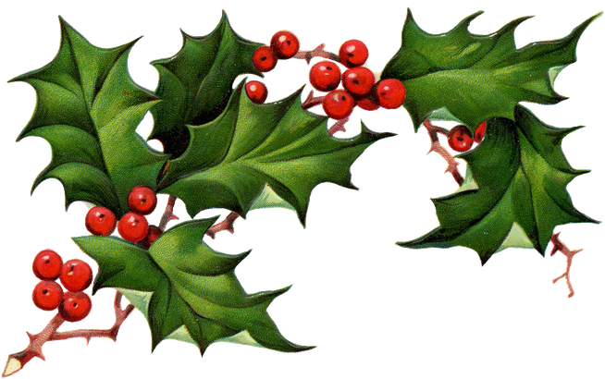
The Ladies Holly Spiel

Glooscap Curling Club
Kentville, NS

November 24, 25, 26
2017

Entry Fee $160.00
First 20 teams with entry fee enclosed
Closing date for entries is November 10th

Luncheon provided for all participants on Saturday
Great prizes for bonspiel winners and runners-up
Every team is a winner

Please e-mail or phone Edna Salter with your intention
(f.salter@ns.sympatico.ca) 902.679.2988

Please send entry form with cheque payable to Glooscap Curling Club to:
Edna Salter
4 Ridgemont Place
Coldbrook, NS B4R 0A3

Note: No refunds after November 1

Skips Name: ____________________________________________
Club: ____________________________________________
Team Members: _________________________________________
_________________________________________________

Email: ________________________________________________

Circle preferred draw time on Friday:

3:45 pm 6:00 pm 8:15 pm


